Using the Binary Search Algorithm and trace table examples at the end of this document, complete the trace tables below for the Color Array. Upload this document to github and submit the link to your repository to the dropbox.

1st search: violet

|  |  |  |  |
| --- | --- | --- | --- |
| **First** | **Last** | **Middle** | **Comparison** |
| 0 | 10 | 5 | Violet>Indigo |
| 6 | 10 | 8 | Violet>Red |
| 9 | 10 | 10 | Violet<yellow |
| 9 | 9 | 9 | Violet=Violet Return=True |

2nd search: green

|  |  |  |  |
| --- | --- | --- | --- |
| **First** | **Last** | **Middle** | **Comparison** |
| 0 | 10 | 5 | Green<Indigo |
| 0 | 9 | 5 | Green<Indigo |
| 0 | 8 | 4 | Green=Green  Return=True |
|  |  |  |  |
|  |  |  |  |

3rd search: yellow

|  |  |  |  |
| --- | --- | --- | --- |
| **First** | **Last** | **Middle** | **Comparison** |
| 0 | 10 | 5 | Yellow>Indigo |
| 1 | 10 | 6 | Yellow>Lavender |
| 2 | 10 | 6 | Yellow>Lavender |
| 3 | 10 | 7 | Yellow>Magenta |
| 4 | 10 | 7 | Yellow>Magenta  Return=False |

**Color array**:

|  |  |
| --- | --- |
| aqua | [0] |
| brown | [1] |
| chartreuse | [2] |
| dark brown | [3] |
| green | [4] |
| indigo | [5] |
| lavender | [6] |
| magenta | [7] |
| red | [8] |
| violet | [9] |
| yellow | [10] |

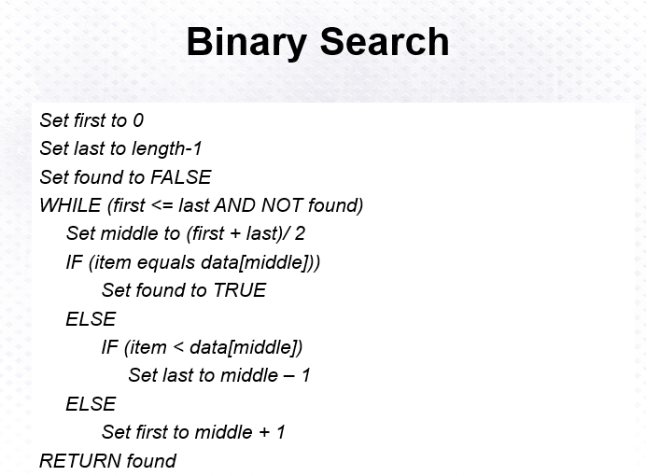

Above: Binary Search Algorithm

